

**OUTREACH SCHOOLS EXAMINATIONS BOARD**

**MID TERM II EXAMINATION 2024**

**P.6 INTEGRATED SCIENCE**

***Time Allowed: 2hours 15 Minutes***

**Pupil’s Name: …………………………………………..……………………**

**Class: …………………………………….………………………………………**

**School Name: ………………………………………………………………….**

|  |  |  |
| --- | --- | --- |
| **FOR EXAMINERS’**  USE ONLY | | |
| **Qn. No.** | **MARKS** | **EXR’S**  **No.** |
| **1 - 10** |  |  |
| **11 – 20** |  |  |
| **21 – 30** |  |  |
| **31 – 40** |  |  |
| **41 – 43** |  |  |
| **44 – 46** |  |  |
| **47 – 49** |  |  |
| **50 - 52** |  |  |
| **53 - 55** |  |  |
| **TOTAL** |  |  |

**Read the following instructions carefully:**

1. This paper has two sections: **A** and **B**
2. Section **A** has 40 questions (40 marks)
3. Section **B** has 15 questions (50 marks)
4. Answer all questions. All the working for both sections A and B must be shown in the spaces provided.
5. All working must be done using a blue or black ball point pen or ink. Any work done in pencil will NOT be marked except drawings and diagram.
6. Unnecessary changes in your work and handwriting that cannot be easily read may lead to loss of marks.
7. Do not fill anything in the table indicated

**“For examiners’ use only”** and the boxes inside the question paper.

***Turn Over***

**SECTION A: 40 MARKS**

1. Give any one use of a beak to a bird.

………………………………………………………………………………………..…………………………

1. How does mulching promote breeding of crop pests?

………………………………………………………………………………………………………………..…

1. Identify one disease which is most likely to affect people due to poor sanitation.

………………………………………………………………………………………………………………….

1. Why are handles of box irons usually made of wood?

………………………………………………………………………………………………………………….

1. Mention one advantage of having shadows in the environment.

…………………………………………………………………………………………………………………

1. How important are gills to a mushroom?

………………………………………………………………………………………………………………….

1. 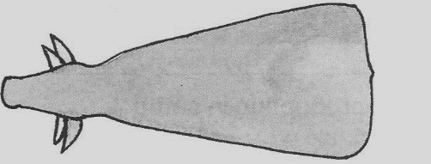Why do farmers prefer keeping a type of cattle whose body shape is shown below?

…………………………………………………………………………………………………………………

1. How is the sun a key to plant life?

………………………………………………………………………………………………………………….

1. What process enables water to change into ice?

…………………………………………………………………………………………………………………

1. Identify one danger of smoking to an individual.

…………………………………………………………………………………………..………………………

1. State one role of bacteria in soil formation.

……………………………….…………………………………………………………………………………

1. Suggest one important activity carried out in a health parade in many schools.

…………………………………………………………………………………………………………………

1. Which type of change is fermentation?

…………………………………………………………………………………………………………………..

1. Why is the practice of draining stagnant water around our houses an important way of promoting PHC?

…………………………………………………………………………………………………………………

1. How do houseflies spread germs in the 4Fs germ path?

…………………………………………………………………………………………………………………..

1. Why does a pencil put in a bucket full of water float?

…………………………………………………………………………………………………………………..

1. Give the difference between podo plant and ground nut plant.

…………………………………………………………………………………………………………………..

1. Write down any one gland which is connected to the duodenum.

…………………………………………………………………………………………………………………..

1. What is the gestation period of a rabbit?

……………………………………………………………………………………………………………………

1. Name the family of plant that have the root system drawn below.

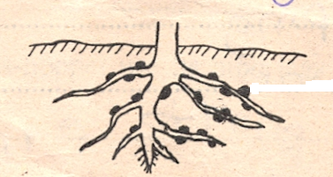

………………………………………………………………………………………………………………..

1. How is the family of plants named above useful to the soil?

…………………………………………………………………………………………………………………

1. The mass of the object below is 240gm. Calculate it’s density.

2cm

3cm

4cm

1. How can camouflaging offer protection to a chameleon?

…………………………………………………………………………………………………………………..

1. Give any one advantage of having litter in a poultry house.

…………………………………………………………………………………………………………………

1. State one characteristic common to all vertebrates.

…………………………………………………………………………………………………………………

1. Briefly explain how a family can prevent the spread of typhoid.

…………………………………………………………………………………………………………………..

1. How is excessive diarrhoea dangerous to one’s health?

…………………………………………………………………………………………………………………..

1. Give one way in which plants benefit from bees visiting them.

…………………………………………………………………………………………………………………..

1. Give any one role played by UNEPI in immunization programme.

…………………………………………………………………………………………………………………

1. Why does venacava carry blood to the heart?

…………………………………………………………………………………………………………………

1. Mention one danger of sharing drugs among patients.

…………………………………………………………………………………………………………………

1. In the space provided below, draw a clear diagram of a leaf showing venation common in monocotyledonous plants.
2. Give a reason why a farmer should have proper record keeping.

…………………………………………………………………………………………………………………..

1. To which group of cold blooded vertebrate do frogs and newts belong?

…………………………………………………………………………………………………………………..

1. Why does a maize plant develop prop roots shortly after flowering?

…………………………………………………………………………………………………………………..

1. Below is a garden tool used by crop farmers. Why is it preferred by farmers for transplanting to other tools?

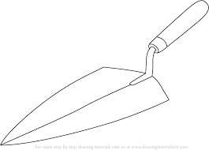

……………………………………………………………………………..…………………………………

1. Give one reason why people should keep the doors and windows open during day time.

………………………………………………………………………………………………………………..

1. Suggest one way how hook worms enter into our bodies.

…………………………………………………………………………………………………………………..

1. What are scavenger birds?

…………………………………………………………………………………………………………………

1. Mention the importance of cold water in a condenser during distillation processing of alcohol.

…………………………………………………………………………………………………………………..

**SECTION B (60 MARKS)**

1. a) What name is given to a mixture of two or more metals?

……………………………………………………………………………………………

b) How does heat move from one point to another in a metal?

……………………………………………………………………………………………

c) State any one effect of heat on matter?

……………………………………………………………………………………………

d) Apart from painting, give any other method of preventing a metallic object from rusting,

……………………………………………………………………………………………

1. **Below is a diagram of a clinical thermometer.**

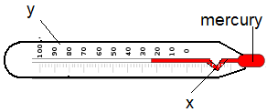

1. Name the parts labelled.
2. X……………………………………………………………………..………………………………
3. y………………………………………………….…………………………………………………
4. Which part of the heart has similar function as part X in the above diagram?

……………………………………………………………………………………………………………

1. Suggest any one advantage of using mercury in a clinical thermometer over alcohol.

………………………………………………………………………………………………………………

1. a) What is agroforestry?

…………………………………………………………………………………………………………………..

b) Give any two advantages of agroforestry.

(i)………………………………………………………………………………………………………………

(ii)………………………………………………………………………………………………………………

c) How do trees purify air around our school and homes?

………………………………………………………………………………………………………………….

1. a) What are vulnerable groups of people?

…………………………………………………………………………………………………………………

b) Mention two examples of vulnerable groups of people.

(i)………………………………………………………………………………………………………………

(ii)……………………………………………………………………………………………………………..

c) Mention one important way of caring for vulnerable groups of people.

………………………………………………………………………………………………………………….

1. **Match items of group A with B correctly.**

**Group A Group B**

Wine chewing

Horoin injected

Cocaine drinking

Miraa sniffing

1. Wine……………………………………………………………………………………………………….
2. Horoin……………………………………………………………………………………………………
3. Cocaine…………………………………………………………………………………………………..
4. Miraa……………………………………………………………………………………………………..
5. a) Give one danger of eating food while talking?

………………………………………………………………………………………………………………….

b) What health habit must be practiced before eating food?

………………………………………………………………………………………………………………….

c) Why should such a health habit be promoted?

…………………………………………………………………………………………………………………..

d) Why are we encouraged to drink water after eating every meal?

…………………………………………………………………………………………………………………..

1. 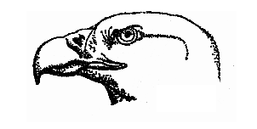**The diagram below shows the head of a bird.**
2. To which group of birds does a bird with such a beak belong?

……………………………………………………………………………………………………………..

1. How is the beak of this bird adapted to its function?

………………………………………………………………………………………………………………

1. How is such a bird similar to a lion in terms of their feeding habits?

……………………………………………………………………………………………………………

1. Mention any one example of a bird with the type of beak drawn above apart from Eagles.

………………………………………………………………………………………………………………

1. a) Name the type of a bee in a hive that develops from unfertilized egg.

………………………………………………………………………………………………………………..

b) Write down two conditions that may encourage swarming in bees.

(i)………………………………………………………………………………………………………………

(ii)…………………………………………………………………………………………………………….

c) Write down one advantage of traditional beehive used for keeping bees.

………………………………………………………………………………………………………………..

1. a) Briefly explain the term transpiration.

…………………………………………………………………………………………………………………..

b) Name two factors that affect the rate of transpiration.

(i)…………………………………………………………………………………….…………………………

(ii)………………………………………………………………………………………………………………

c) Give one way some plants control the rate of transpiration.

…………………………………………………………………………………………………………………..

1. a) Identify the essential sex organ removed from the Billy goat during castration exercise.

…………………………………………………………………………………………………………………

b) Write down two advantages of castration.

(i)………………………………………………………………………………………………………….…

(ii)…………………………………………………………………………………………………………….

c) Which machine does a farmer require so as to castrate billy goats.

……………………………………………………………………………………………..…………………

1. a) Write short sentences about the following terms used in sound energy.
2. Volume: ……………………………………………………………………………………………
3. Echo: ……………………………………………………………………………………………

b) To which group of musical instruments does a tube fiddle belong?

……………..…………………………………………………………………………………………

c) Mention any one device used to store sound.

……………………………………………………………………………………………………………….

1. **Below is a figure of a flower.**

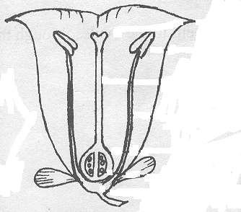 J

W P

K

1. Name the parts marked;
2. W……………………………………………………………………………………………………..
3. J………………………………………………………………………………………………………
4. Mention the function of part K to a flower.

……………………………………………………………………………………………………………..

1. What name is given to the female part of a flower?

………………………………………………………………………………………………………………

1. a) What is heat period in livestock keeping?

…………………………………………………………………………………………………………………

b) Write down any two signs of heat period?

(i)………………………………………………………………………………………………………….……

(ii)………………………………………………………………………………………………………………

c) Identify the structure that connects the placenta to the foetus.

………………………………………………………………………………………………………………….

1. 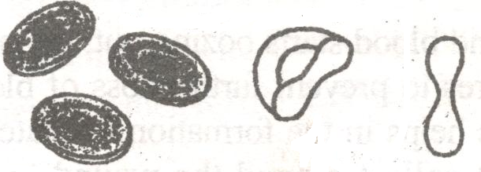**Red blood cells have got a definite shape as shown in A.**

**A B**

1. Which disease makes the red blood cells assume a shape as shown in B?

………………………………………………………………………………………………………………

1. Mention the function of red blood cells in the body.

………………………………………………………………………………………………………………

1. How important is the heart in the human body?

……………………………………………………………………………………………………………

1. Mention any one use of blood in the body.

………………………………………………………………………………………………………………

1. **Study the table below and answer questions that follow.**

**Y K X**

Sardines Cobra Dolphin

Nile perch Gecko Whale

Lung fish Chameleon Seals

1. Give the similarity between animals in group Y and K.

………………………………………………………………………………………………………………

1. To which group of vertebrates do animals X belong?

……………………………………………………………………………………………………………..

1. How are animals in Y different from animals in X in terms of reproduction?

………………………………………………………………………………………………………………

1. Identify one method of conserving animals in group Y.

……………………………………………………………………………………………………………..

***“GOOD LUCK”***